Preparation of Papers for AJSAE 2026
(Bold-faced Times New Roman, 14pt)

Authors^{1*}, Authors^{2**}, and Authors³ (Times New Roman, font size 11)
¹Department, Affiliation, City, Country (Times New roman font size 11)
²Department, Affiliation, City, Country (Times New roman font size 11)
³Department, Affiliation, City, Country (Times New roman font size 11)

*E-mail: ABCD@abcd.com (Times New Roman font size 11)
**E-mail: ABCD@abcd.com (Times New Roman font size 11)

Abstract
Authors should submit abstracts which are in the form of paper summary. The abstract should describe objectives, results, innovative steps and the significance of your work. Authors should submit abstracts which are in the form of paper summary. The abstract should describe objectives, results, innovative steps and the significance of your work. Authors should submit abstracts which are in the form of paper summary. The abstract should describe objectives, results, innovative steps and the significance of your work. Authors should submit abstracts which are in the form of paper summary. The abstract should describe objectives, results, innovative steps and the significance of your work. Authors should submit abstracts which are in the form of paper summary. The abstract should describe objectives, results, innovative steps and the significance of your work. (in the up to 200 words, Times New Roman, font size 10)

Keywords: Keywords1, Keywords2, Keywords3, Keywords4, Keywords5 (Times New Roman, font size 10, upper case at the beginning of each Keywords)

1. Introduction
Wind power is the most useful renewable energy. Between 2005 and 2010 the average annual growth rate in new installations was 27.6 percent [1]. The most important factor in wind energy generation is selection of good location where wind flow is strong and consistent. In this reason, many wind turbines are constructed on mountains or offshore sites using tall towers. The tower height has grown from 40 meters to 90 meters over the past 20 years. This trend is still going on to exceed 100 meters. However, even 100 meters or 150 meters, it is not sufficient increment. Typically, in daytime, doubling the altitude increases the expected wind speed by 10%, which means the expected power by 34% more [2]. Therefore, recent years have seen significant advances in technologies to generate electricity from high altitude winds that of hundreds or thousands meters above. Some of these technologies are KiteGen using controlled tethered airfoils [3], Magenn aerostat using a vertical-axis wind turbine [4], a parawing on ships [5], and several non-airborne concepts [6]. As another novel high altitude wind power system, this paper describes a cycloidal wind turbine mounted on a tethered balloon or parafoil as shown in Fig. 1 [7].
All manuscripts are to be submitted online via the AJSAE 2026 homepage at ajsae2026.org. (Times New Roman, font size 10)
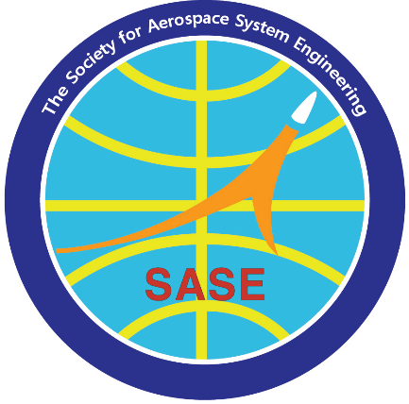
Fig. 1 Figure Title (Times New Roman, font size 10)

Paper Format
You have to use a single space, two-column format in A4 paper. (210 × 297 mm.) Figures are not required to be in two-column format. You must have a right, left, top, and bottom margin of 20 mm.

Headings
Major headings and subheadings be placed flush left of the column on a separate line. All the headings should be bold-faced.

References
When referring to references in the text, at the end of sentence, type the numerals in square bracket. (ex: [1], [2], [3]) and Put a group at the end of paper.

Figures and Tables
Figures and Tables Serial numbers (ex: Fig. 1, Table 1) and captions should be attached to figures and Tables. Figure number and caption should be centered at the bottom of the figure and Table number and caption should be centered on the top of the table. Figures and Tables should be of clear image quality.

Equations
SI units should be used. Equations should be numbered consecutively and located at the right margin as in Eq. (1).

$a^{2}+b^{2}=c^{2}$ (1)
2. Title of Section
2.1. Title of Subsection
Type your main text in Times New Roman 10point, Type your main text in Times New Roman 10point, Type your main text in Times New Roman 10point, Type your main text in Times New Roman 10point, Type your main text in Times New Roman 10point, Type your main text in Times New Roman 10point, Type your main text in Times New Roman 10point, Type your main text in Times New Roman 10point, Type your main text in Times New Roman 10point, Type your main text in Times New Roman 10point, Type your main text in Times New Roman 10point,

3. Title of Section
3.1. Title of Subsection
Type your main text in Times New Roman 10point, Type your main text in Times New Roman 10point, Type your main text in Times New Roman 10point, Type your main text in Times New Roman 10point, Type your main text in Times New Roman 10point, Type your main text in Times New Roman 10point, Type your main text in Times New Roman 10point, Type your main text in Times New Roman 10point, Type your main text in Times New Roman 10point, Type your main text in Times New Roman 10point, Type your main text in Times New Roman 10point, Type your main text in Times New Roman 10point, Type your main text in Times New Roman 10point, Type your main text in Times New Roman 10point,

Table 1 Table Title (Times New Roman, font size 10)

Conclusions
You should clearly state your conclusions, You should clearly state your conclusions, You should clearly state your conclusions, You should clearly state your conclusions, You should clearly state your conclusions, You should clearly state your conclusions, You should clearly state your conclusions, You should clearly state your conclusions, You should clearly state your conclusions, (Times New Roman, font size 10)

Acknowledgement
The Acknowledgment section, if used, must be placed before the References. Sponsorship or financial support acknowledgment should be included here. (Times New Roman, font size 10)

References
[1] H. Gildong, “Propulsion and Thermodynamics,” JASE, vol. 100, pp. 1-10, July 2023.
[2] H. Gildong and J. Bogo, “Materials and Structures,” International Journal of Aerospace System Engineering, vol. 10, no. 1, pp. 92-100, October 2022.

